Daisy-Chained Sensor Suite
Hardware Reference Manual
Revision 1.1 (Draft)
11/08/26
Team Gleba


Table of Contents
Table of Contents 2
Board Overview 3
Block Diagram 3
Design Goals 3
Relevant Components 4
Extra Sections 8
RP2040 Pin Map 8
I2C Address Map 9
SPI Connectors Pinout 10
Engineering Change Orders 12
Revision 1.0 (initial build) 12
Appendix A: Schematics 12
Appendix B: Manufactured Board Status 13
Appendix C-Onwards: Extra Info 13

Board Overview

Block Diagram
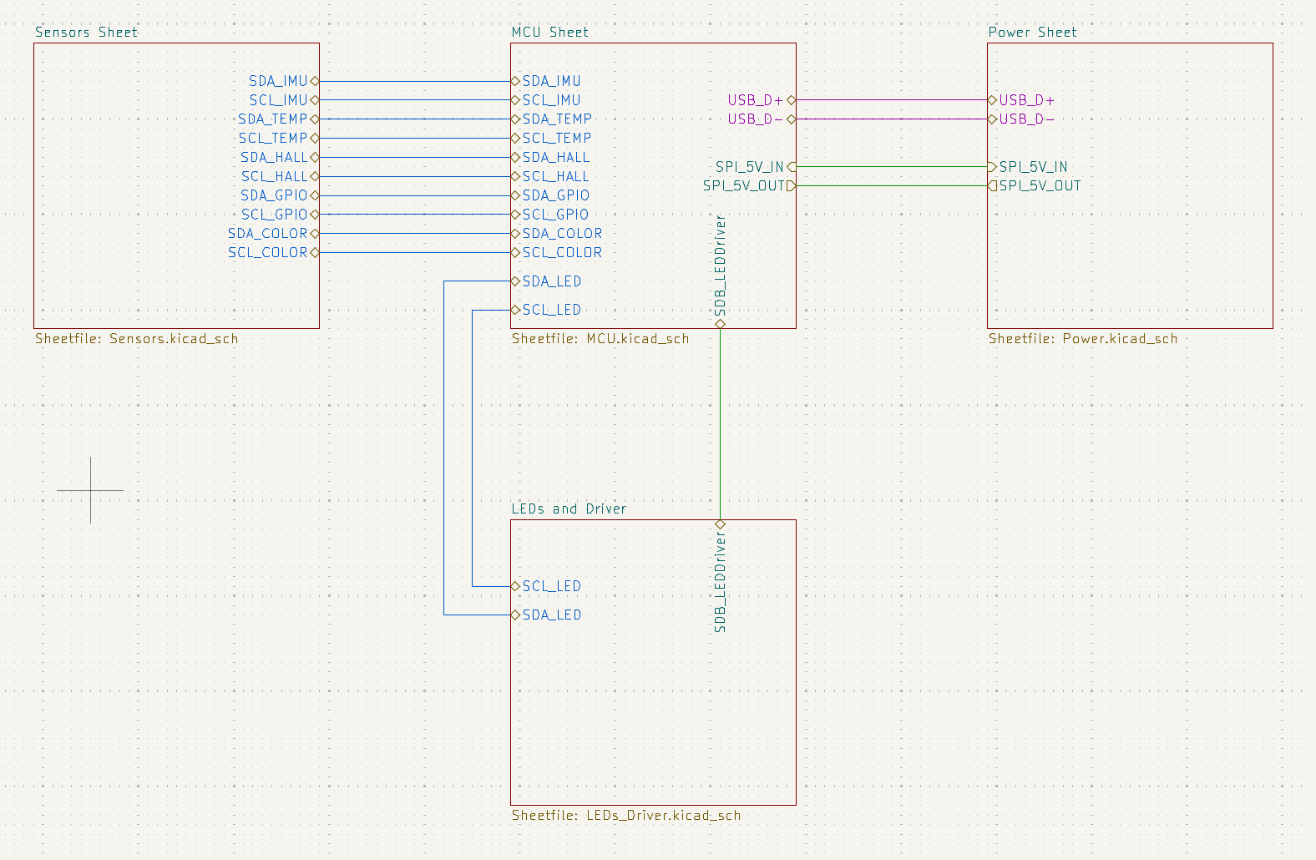

Design Goals
- Receive input SPI from a previous board and output SPI to the next board to form a daisy chain to send an information packet down.
  - Power only from the first in the chain
- Micro USB programming and Powering
  - Power MUX input from SPI and USB
  - Reverse voltage protection on SPI
  - 5v -> 3.3v Board voltage
- I2C Sensors (Separate I2C buses each)
  - IMU
  - Color Sensor
  - Hall Effect
  - Temperature Sensor
  - GPIO Expanded DIP switch
  - PWM LED Array
  - As drawn (schematic Rev 11.7.1): every device has its own I2C bus (6 SDA/SCL pairs), each with 4.7 kΩ pull-ups. The RP2040 has two I2C controllers, so three buses use I2C0 and three use I2C1 (see I2C Address Map).
  - Interrupt lines are not used; all sensor INT/OS pins are left unconnected.
- Test Points for important signals/voltages
  - TP1–TP12: VBUS, SPI_5V_IN, SPI_5V_OUT, +3V3, 2× GND, and SCK / MOSI / CSN on both SPI IN and SPI OUT.
- 4 Mounting Holes (M2)

Relevant Components
- MCU
  - RP2040
    - 2 MB external Flash memory (W25Q16JVUXIQ TR) datasheet
    - 12 MHz Crystal (ABM8-272-T3) datasheet
    - Reset and Boot buttons (SKRPABE010) datasheet
    - RP2040 (U1): dual-core Arm Cortex-M0+ (up to 133 MHz), 264 kB SRAM, no internal flash; 2× SPI, 2× I2C, 8 PIO state machines, USB 1.1 device.
    - Flash (U9): W25Q16JV (16 Mbit = 2 MB) on the dedicated QSPI pins (QSPI_SCLK, SD0–SD3, SS). All program code runs from here.
    - Crystal (Y1): 12 MHz with 15 pF load capacitors (C16, C27) and a 1 kΩ series resistor (R42) on XOUT, as in the RP2040 Hardware Design Guide minimal design.
    - Supplies: IOVDD, USB_VDD, ADC_AVDD and VREG_VIN on +3V3 (8× 100 nF + 1 µF). The internal regulator output VREG_VOUT feeds DVDD (+1V1) with 1 µF + 2× 100 nF.
    - RESET (S7): pulls RUN to GND; 1 kΩ pull-up R71. BOOTSEL (S6): pulls QSPI_SS low through R43 (1 kΩ). Hold BOOTSEL while pressing RESET (or plugging in USB) to enter the USB mass-storage bootloader.
    - USB: D+/D- through 27.4 Ω series resistors (R41, R40), per the design guide.
- I2C Sensors
  - IMU
    - ICM-42605 datasheet
    - 6-axis IMU (3-axis accelerometer + 3-axis gyroscope), 16-bit outputs. Accel ±2/4/8/16 g, gyro up to ±2000 dps. On-chip FIFO and temperature sensor.
    - Interface: I2C mode (AP_CS tied to +3V3). AP_AD0 tied to GND → address 0x68. VDD and VDDIO on +3V3.
    - Bus: own I2C bus, SDA = GPIO0 / SCL = GPIO1 (I2C0), pull-ups R72 / R70. INT1 is not connected; INT2/FSYNC and RESV pins are tied to GND.
    - Firmware notes: WHO_AM_I (0x75) should read 0x42. The sensor starts in sleep; turn accel/gyro on with PWR_MGMT0 (0x4E). Data registers are big-endian (high byte first), which matches the packet format (bytes 0–11).
    - Placement: keep near the board center, away from mounting holes and connectors, to reduce mechanical stress on the sensor.
  - Color Sensor
    - VEML3328 datasheet
    - RGB + Clear + IR light sensor, 16-bit per channel. Fixed address 0x10. No interrupt pin.
    - VDD on +3V3 (2.6–3.6 V) with local decoupling. Bus: SDA = GPIO24 / SCL = GPIO25 (I2C0), pull-ups R82 / R83.
    - Placement: needs a clear view of the light source; keep it away from the RGB LED array so the LEDs do not saturate it.
  - Hall Effect
    - TMAG5273C1QDBVR datasheet
    - Part: the schematic uses TMAG5273A2QDBVR (matches the README part list). The C1 part number above is from an earlier draft. A2 = ±133/±266 mT range, address 0x35 (factory default).
    - 3-axis linear Hall-effect sensor: X/Y/Z field, temperature, and on-chip angle calculation.
    - VCC on +3V3 (1.7–3.6 V). TEST pin tied to GND. ~INT is not connected. Bus: SDA = GPIO4 / SCL = GPIO5 (I2C0), pull-ups R78 / R79.
  - Temperature Sensor
    - LM75ADP datasheet
    - Digital temperature sensor, 11-bit (0.125 °C steps), −55 °C to +125 °C, 2.8–5.5 V supply (on +3V3).
    - A2, A1, A0 tied to GND → address 0x48. OS (over-temperature output) is not connected. Bus: SDA = GPIO2 / SCL = GPIO3 (I2C1), pull-ups R76 / R77.
    - Placement: away from the LDO and LED driver so it reads board/ambient temperature, not a hot spot.
  - GPIO Expander
    - TCA9534PWR datasheet
    - DIP Switch (DS01C-254-L-08BE) datasheet
    - Resistor Network (YC158TJR-0710KL) datasheet
    - TCA9534: 8-bit I2C I/O expander. A0 = +3V3, A1 = A2 = GND → address 0x21.
    - P0–P7 read DIP switches SW0–SW7. Each line has a 10 kΩ pull-up (RN1) to +3V3 and the switch shorts it to GND, so switch ON reads 0.
    - ~INT is not connected. Bus: SDA = GPIO22 / SCL = GPIO23 (I2C1), pull-ups R80 / R81. All pins are inputs after power-on (default).
    - Packet byte 20 = input register (P7..P0).
  - LED Controller
    - IS31FL3254-QFLS4-TR datasheet
    - 8x RGB LEDS (CLMVC-FKA-CL1D1L71BB7C3C3) datasheet
    - IS31FL3254: 24-channel constant-current LED driver (8 RGB LEDs × 3 colors), 2.7–5.5 V (on +3V3), I2C up to 1 MHz. AD tied to GND → address 0x30. Bus: SDA = GPIO26 / SCL = GPIO27 (I2C1), pull-ups R84 / R85.
    - Current set: R_ISET = 10 kΩ (R22) → about 7.6 mA max per channel (I_OUT = 78.25 × 0.97 V / R_ISET), 22.8 mA per RGB LED, 182 mA for all 8. Actual current = I_OUT(MAX) × GCCx / 256 × PWM duty, set in firmware.
    - Shutdown: SDB (active-low) → GPIO6 with 100 kΩ pull-down R21 and 100 nF C26, so the driver stays off until firmware drives GPIO6 high.
    - LEDs D31–D38: common anode on +3V3; cathodes on OUT1–OUT24 in R, G, B order (LED n uses OUT 3n−2, 3n−1, 3n). 7.6 mA keeps the G/B LED forward voltage plus driver headroom below the 3.3 V supply.
- Connectors
  - Micro USB
    - 10118194-0001LF datasheet
    - USB Micro-B receptacle (J1). VBUS powers the board; D+/D- go to the RP2040 USB PHY for programming (BOOTSEL) and USB serial.
    - Protection: USBLC6-2SC6Y (D1) ESD array on D+/D-/VBUS, SMBJ5.0CA TVS (D28) on VBUS, 750 mA polyfuse (F1). ID pin unconnected. Shield is not tied directly to GND: 1 MΩ (R75) ∥ 4.7 nF (C32) to GND.
  - SPI
    - S6B-PH-K-S datasheet
    - JST PH 2.0 mm, 6-pin, side entry. J9 = IN (from previous board, SPI0 slave). J7 = OUT (to next board, SPI1 master). See SPI Connectors Pinout.
    - Link settings: 1 MHz, SPI mode 3, 56-byte packet. 5 V is passed from the board rail to J7 pin 5, so only the first board in the chain needs USB power.
- Power
  - 3.3V Linear Regulator
    - AP2112K-3.3 datasheet
    - 5 V rail → +3V3 for the MCU and all sensors. Up to 600 mA output, about 250 mV dropout at 600 mA. EN tied to VIN (always on). 1 µF input (C29) and output (C30) capacitors.
    - Expected load is about 45 mA per board, plus up to 182 mA on the one board whose LED array is on. A 6-board chain draws about 6 × 45 + 182 = 452 mA (schematic power note), under the 750 mA fuse hold current.
  - Power MUXing Diodes
    - LM66100DCK datasheet
    - Two LM66100 ideal diodes (1.5–5.5 V, 1.5 A max) OR the two 5 V sources onto the 5 V rail and block reverse current, so USB power and SPI power never touch.
    - U2 (USB path): always enabled (~CE = GND). U10 (SPI path): ~CE is driven by the fused USB voltage (100 kΩ pull-down R29). With USB present, U10 turns off, so USB has priority; without USB, U10 passes the previous board’s 5 V.
    - SPI-side input protection: SMBJ5.0CA TVS (D29) and 750 mA polyfuse (F2).
- Debug
  - General Purpose LEDs (3)
    - 0603 LEDs datasheet (might need to look more into this)
    - D39 / D40 / D41 on GPIO8 / GPIO9 / GPIO10. Anode to +3V3, cathode through 1 kΩ (R37–R39) to the GPIO, so they are active-low (drive 0 to turn on).
    - Power indicator D30 (1 kΩ R28) lights when +3V3 is present.
  - General Purpose Buttons (2)
    - SKRPABE010 datasheet
    - S4 → GPIO16, S5 → GPIO17. The button shorts the line to GND and a 10 kΩ pull-up (R74 / R73) holds it high, so it reads 0 when pressed.
    - Debounced in hardware: 100 nF (C17 / C31) to GND with the 10 kΩ pull-up gives τ ≈ 1 ms. Firmware can still add a short software debounce.

Extra Sections

RP2040 Pin Map
From the schematic (Rev 11.7.1). Every SPI and I2C pin matches the RP2040 hardware function table, so the hardware SPI/I2C peripherals can be used directly. Each sensor has its own I2C bus; firmware selects a bus by switching the pin functions of I2C0 or I2C1.
GPIO | Net | Function | Notes
0 | SDA_IMU | I2C0 SDA | IMU bus, 4.7 kΩ pull-up (R72)
1 | SCL_IMU | I2C0 SCL | IMU bus, 4.7 kΩ pull-up (R70)
2 | SDA_TEMP | I2C1 SDA | Temperature bus (R76)
3 | SCL_TEMP | I2C1 SCL | Temperature bus (R77)
4 | SDA_HALL | I2C0 SDA | Hall bus (R78)
5 | SCL_HALL | I2C0 SCL | Hall bus (R79)
6 | SDB_LEDDriver | Output | IS31FL3254 enable (high = on), 100 kΩ pull-down
7 | — | Unused
8 | LED D39 | Output | Debug LED 1, active-low
9 | LED D40 | Output | Debug LED 2, active-low
10 | LED D41 | Output | Debug LED 3, active-low
11 | — | Unused
12 | SPI_OUT_MISO | SPI1 RX | J7 pin 3
13 | SPI_OUT_CSN | SPI1 CSn | J7 pin 1, TP12
14 | SPI_OUT_SCK | SPI1 SCK | J7 pin 4, TP10
15 | SPI_OUT_MOSI | SPI1 TX | J7 pin 2, TP11
16 | GPIO16 | Input | Button S4, active-low, RC debounced
17 | GPIO17 | Input | Button S5, active-low, RC debounced
18 | SPI_IN_SCK | SPI0 SCK | J9 pin 3, TP7
19 | SPI_IN_MISO | SPI0 TX | J9 pin 4
20 | SPI_IN_MOSI | SPI0 RX | J9 pin 5, TP8
21 | SPI_IN_CSN | SPI0 CSn | J9 pin 6, TP9
22 | SDA_GPIO | I2C1 SDA | GPIO expander bus (R80)
23 | SCL_GPIO | I2C1 SCL | GPIO expander bus (R81)
24 | SDA_COLOR | I2C0 SDA | Color sensor bus (R82)
25 | SCL_COLOR | I2C0 SCL | Color sensor bus (R83)
26 | SDA_LED | I2C1 SDA | LED driver bus (R84)
27 | SCL_LED | I2C1 SCL | LED driver bus (R85)
28–29 | — | Unused | Can be ADC inputs (ADC2/ADC3)
RUN | — | Reset | Button S7, 1 kΩ pull-up
QSPI_SS | — | Boot select | Button S6 (BOOTSEL) via 1 kΩ

I2C Address Map
Each device has its own bus with 4.7 kΩ pull-ups to +3V3. 400 kHz is supported by every device. Only two I2C controllers exist, so before talking to a device firmware routes its controller to that pin pair with gpio_set_function(); the other two pairs on the same controller are switched back to plain GPIO (inputs) first.
Device | Ref | Addr | Address pins | SDA / SCL | Controller
ICM-42605 IMU | U3 | 0x68 | AP_AD0 = GND | GPIO0 / GPIO1 | I2C0
LM75ADP temperature | U6 | 0x48 | A2..A0 = GND | GPIO2 / GPIO3 | I2C1
TMAG5273A2 Hall | U12 | 0x35 | fixed by variant (A) | GPIO4 / GPIO5 | I2C0
TCA9534 GPIO expander | U7 | 0x21 | A0 = VCC, A1 = A2 = GND | GPIO22 / GPIO23 | I2C1
VEML3328 color | U4 | 0x10 | fixed | GPIO24 / GPIO25 | I2C0
IS31FL3254 LED driver | U8 | 0x30 | AD = GND | GPIO26 / GPIO27 | I2C1

SPI Connectors Pinout
Main spreadsheet can be found at this link.
Pin Number | Direction | Pin Type | Pin Function | Description
1 | IN | GND | Ground Reference | Ground Reference
2 | IN | 5V IN | 5V Input | 5V from previous board
3 | IN | SPI | SPI0 SCK | Master SPI Clock Input
4 | IN | SPI | SPI0 TX | SPI Data Out, MISO (Master In, Slave Out) with respect to prev board
5 | IN | SPI | SPI0 RX | SPI Data In, MOSI (Master Out, Slave In) with respect to prev board
6 | IN | SPI | SPI0 CSN | Master SPI Chip Select, Active Low
6 | OUT | GND | Ground Reference | Ground Reference
5 | OUT | 5V OUT | 5V Output | 5V to next board
4 | OUT | SPI | SPI1 SCK | Slave SPI Clock Output
3 | OUT | SPI | SPI1 RX | SPI Data In, MISO (Master In, Slave Out) with respect to current board
2 | OUT | SPI | SPI1 TX | SPI Data Out, MOSI (Master Out, Slave In) with respect to current board
1 | OUT | SPI | SPI1 CSN | Slave SPI Chip Select, Active Low
*OUT must match IN when aligned face to face.
On our board J9 is IN and J7 is OUT. J9: pin 3 SCK = GPIO18, pin 4 = GPIO19 (SPI0 TX), pin 5 = GPIO20 (SPI0 RX), pin 6 CSn = GPIO21. J7: pin 1 CSn = GPIO13, pin 2 = GPIO15 (SPI1 TX), pin 3 = GPIO12 (SPI1 RX), pin 4 SCK = GPIO14. OUT pins 2/3 above were corrected to TX/RX to match the schematic.
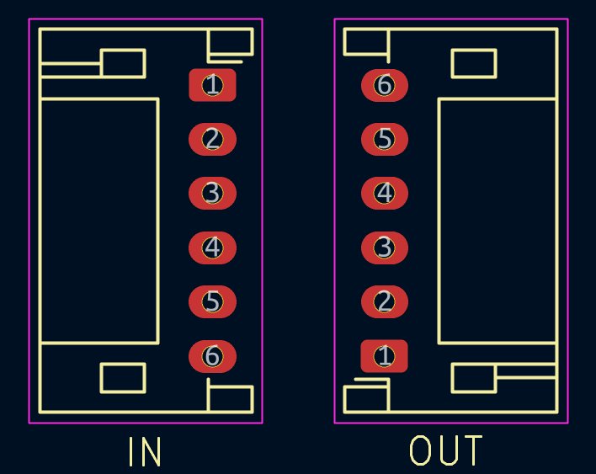

Engineering Change Orders
Any modifications made post-manufacture are documented here.

Revision 1.0 (initial build)
No board has been manufactured yet.

Appendix A: Schematics
KiCad project MiniProject_Schematic_11.7.1 on the gleba branch of RoboJackets/robocup-pcb-miniprojects (github.com/RoboJackets/robocup-pcb-miniprojects/tree/gleba). Root sheet MiniProject.kicad_sch with sub-sheets: MCU, Power, Sensors, LEDs and Driver. Attach a PDF export here once the schematic is frozen.

Appendix B: Manufactured Board Status
No boards built yet.

Appendix C-Onwards: Extra Info
Revision history
- Rev 1.0 draft (11/02/26): filled in from schematic Rev 11.2.2 by Team Gleba. Pin and address tables were taken from the schematic netlist.
- Rev 1.1 draft (11/08/26): updated to schematic Rev 11.7.1: separate I2C bus per device, interrupt lines removed, LED anodes moved to +3V3 with R_ISET = 10 kΩ, test points TP1–TP12, USB shield RC, 27.4 Ω USB resistors.
- Reference: RP2040 Hardware Design Guide (minimal design) for the MCU, flash, crystal and USB circuits.

